Great Basin Outdoor School
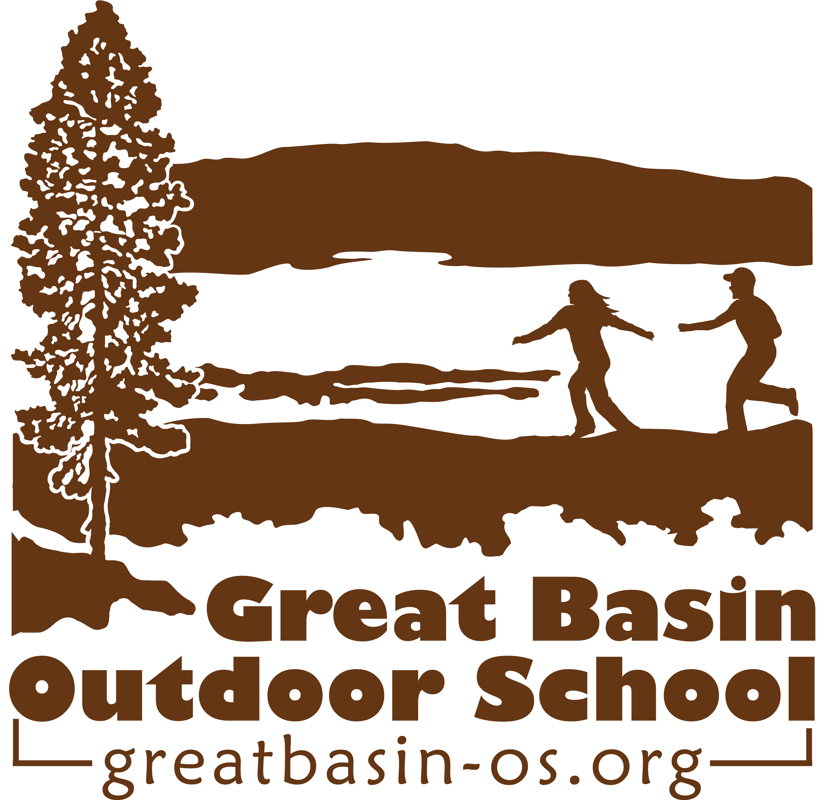

Scholarship Application

This form is to be filled out by the student’s parent or guardian. Please note that all information submitted on this scholarship application form will be kept strictly confidential.

School: ______________________________________ Date __________________

Student Applying for Scholarship: _________________________

Age: ________________ Grade: _________________

Please describe how the student would specifically benefit from attending Great Basin Outdoor School.

Why are you, the parents, interested in an outdoor school experience for your child?

What is the student most looking forward to if they were awarded the scholarship?

Is there anything else you’d like us to know about this student?

Scholarship Follow-Up

School: ______________________________________ Date _______________________

Student Benefiting from Scholarship: ___________________________________________

Name of person filling out this follow-up: _________________________________________

When did the student attend a Great Basin Outdoor School program?

What do you believe the student specifically got out of the Great Basin experience?

In the student’s own words, what did he/she think about the experience? What did he/she specifically learn?

Is there anything else you’d like us to know about the student’s experience?

Please sign here if we can use some of these follow-up comments anonymously in our publications.

Name: __________________________ Signature: ______________________________

